**BANANA FIBRES TO FLUFF TO**

**SANITARY**

**PADS PROJECT**

Table of Contents

* Executive Summary
* Introduction
  + Background and Motivation
  + Product Description
  + Market Analysis and Opportunities
* Manufacturing Plan
  + Raw Material Sourcing
  + Factory Setup and Layout
  + Equipment and Machinery
  + Manufacturing Process
  + Quality Control and Sanitization
  + Packaging
  + Waste Management
* Organizational Plan
  + Company Overview
  + Management Team and Key Personnel
  + Financial Plan and Projections
* Marketing and Sales Strategy
  + Target Customers
  + Pricing
  + Distribution Channels
  + Promotions Strategy
* Implementation Timeline
* Risks and Mitigation Strategies
* Regulatory Environment
  + Product Testing and Certification
  + Legal and Compliance
* Conclusion
* References

Establishing a sanitary pad manufacturing company using banana fibers as the core absorbent material. The company will be located in Sauraha, Chitwan, and aims to produce 50,000 pads per month to serve middle-class Nepali women aged 21-45 concerned about health and the environment. Banana stems wasted yearly in the region will provide an ample, sustainable raw material source. The banana fiber pads are compostable and plastic-free, providing an eco-friendly alternative to conventional pads. A farmer with at least a 1-acre farm staffed by 5 employees will perform fiber extraction. A separate fluff processing, pad fabrication, sanitization, quality control, packaging, and distribution facility will be established in Kathmandu. Pads will be marketed directly to customers through schools, NGOs, shops, and medical stores. The timeline targets factory setup completion in 2025. Regulatory compliance and safety testing will be conducted before launch. This innovative business model supports agricultural communities in Nepal while meeting an important need for women nationwide.

**Introduction**

**Background and Motivation**

Sanitary pads available in the Nepali market today contain plastics and superabsorbent polymers that take centuries to decompose after disposal. This poses significant environmental threats. Most products are manufactured by multinational corporations, resulting in profits leaving Nepal. This business will manufacture 100% biodegradable sanitary pads from banana plant fibers, a waste product from local agriculture. Using banana fiber pads allows women to have safe, sustainable, and affordable menstrual hygiene solutions while also supporting communities in Chitwan. The business prevents waste from banana cultivation and provides income to Nepali citizens.

**Project Descriptions**

Climate change is a pressing issue in the Chitwan district, as it is in many other parts of the world. The district experiences a subtropical climate, characterized by hot and humid summers and mild winters. However, in recent years, the district has been witnessing changes in its climate patterns, which are believed to be linked to climate change. The increased frequency and intensity of extreme weather events such as floods, landslides, and droughts are some of the major consequences of climate change. The district has experienced several devastating floods in recent years, causing extensive damage to homes, crops, and infrastructure. The floods have also led to the loss of human lives and the displacement of people from their homes. Agriculture has been one of the major sectors which has been facing the major consequences of climate change.

Chitwan district is located in the southern region of Nepal and covers an area of 2,238 square kilometers. The district has a population of approximately 579,984 people and is known for its diverse flora and fauna, including the endangered one-horned rhinoceros and Bengal tiger. However, the district is facing significant impacts from climate change, including increased frequency and intensity of extreme weather events, changing rainfall patterns, and the loss of biodiversity. Agriculture, the main source of livelihood for many people in the district, is also under threat due to these impacts.

The district receives most of its rainfall during the monsoon season from June to September. However, in recent years, there has been a shift in the onset and duration of the monsoon season, leading to either prolonged or shortened rainy seasons. This change in rainfall pattern has had significant implications for agriculture, which is the main source of livelihood for many people in the district. Farmers in the region rely heavily on monsoon rains for their crops, but in recent years, there have been increasing instances of droughts and erratic rainfall. This has resulted in lower crop yields and reduced agricultural productivity.

Higher temperatures have led to the emergence of new pests and diseases, which have affected crop growth and production. In addition, the hotter weather has made it harder for farmers to work in the fields, leading to a decrease in agricultural labor productivity.

It is also affecting the availability of water for agriculture in Chitwan. Water availability is becoming increasingly uncertain. This is leading to greater competition for water resources, which can result in conflicts between farmers and communities.

To solve this global issue there is a need for a local solution.

Banana farming is a significant agricultural activity in Chitwan, with bananas grown on 1,503 hectares of land. Banana farming generates a considerable amount of agricultural waste, including banana stems, leaves, and fruit peels. This waste is often left to decompose in the fields or discarded in landfills, which can have negative environmental impacts. However, there is an opportunity to use this waste for value-added products, such as handicrafts and organic fertilizers.

Banana fiber sanitary pads are a sustainable and eco-friendly solution for menstrual hygiene management. With climate change posing a significant threat to the Chitwan district of Nepal, developing banana fiber sanitary pads can contribute to climate resilience and mitigate the impact of climate change on women's livelihoods. This proposal aims to explore the potential of banana fiber sanitary pads and their benefits for the local community.

One potential application of banana waste is the production of sanitary pads made from banana fiber. Sanitary pads are an essential item for women's menstrual hygiene management, but many women in the Chitwan district face challenges accessing affordable and hygienic products. Developing banana fiber sanitary pads could address these challenges while also contributing to climate resilience and mitigating the impact of climate change.

Banana fiber has several advantages over other materials used for sanitary pads, such as cotton or synthetic materials. Banana fiber is biodegradable, compostable, and has antibacterial properties, making it a sustainable and eco-friendly alternative. Additionally, banana fiber is readily available in the Chitwan district, and its use can create a new market for banana waste products, providing additional income for farmers.

The production of banana fiber sanitary pads can also contribute to the local economy by creating job opportunities for women. Women can be trained to produce banana fiber sanitary pads, providing them with a source of income and economic empowerment. The production of banana fibre sanitary pads can also be linked to other value-added products made from banana waste, such as handicrafts, creating a more diversified and sustainable income stream for women.

The use of banana fiber sanitary pads can also have positive health outcomes for women. Many traditional menstrual products, such as cloth pads, are not hygienic and can lead to infections and other health issues. Banana fiber sanitary pads are hygienic and have antibacterial properties, reducing the risk of infection. Additionally, the use of banana fiber sanitary pads can reduce the environmental impact of traditional menstrual products, such as disposable pads, which can take hundreds of years to decompose in landfills.

Its production can also contribute to climate change mitigation. The use of banana waste for value-added products, such as sanitary pads, reduces the amount of waste left to decompose in the fields or discarded in landfills. Additionally, the production of banana fiber sanitary pads reduces the use of non-renewable resources, such as synthetic materials used in disposable pads, which contribute to greenhouse gas emissions.

Banana farming generates a large amount of waste loss that can be used in the production of this pad. On average, a hectare of banana plantations produces 220 tonnes of waste annually. This huge amount of agri-waste creates Methane, a greenhouse gas that is harmful to the environment. *(Agri-food waste)*

[*https://papyrusaustralia.com.au/2021/12/agri-food-waste/*](https://papyrusaustralia.com.au/2021/12/agri-food-waste/)

In conclusion, developing banana fiber sanitary pads in the Chitwan district has the potential to contribute to climate resilience, enhance women's livelihoods, and mitigate the impact of climate change. The production of banana fiber sanitary pads can create a new market for banana waste products, provide job opportunities for women, and contribute to sustainable and eco-friendly

**Adaptation and Mitigation Aspect of the Intervention**

Banana farming has the potential to contribute to climate change adaptation and mitigation efforts in the Chitwan district. Here are some ways in which banana farming can help:

Diversification of crops: With changing weather patterns, farmers in the Chitwan district are facing challenges in traditional crop production. Banana farming can provide an alternative source of income and help farmers diversify their crops. Bananas are also less vulnerable to climate extremes such as droughts and floods, making them a more resilient crop.

Soil conservation: Banana plants have deep roots that can help prevent soil erosion, which is a common problem in the region due to heavy rainfall and floods. This can help conserve soil and prevent nutrient loss, which can improve agricultural productivity.

Water conservation: Banana plants have a high-water use efficiency, meaning they require less water compared to other crops. This can help conserve water resources in a region where water scarcity is becoming an increasingly pressing issue due to climate change.

Carbon sequestration: Banana plants absorb carbon dioxide from the atmosphere and store it in their biomass and soil. This can help mitigate climate change by reducing the amount of greenhouse gases in the atmosphere.

Value-added products: The intervention aims to utilize the banana waste for banana fiber which will ultimately be used for making sanitary pads by the poor and marginalised women. Besides that, it can be used for other handicrafts and organic materials whereas bananas can be used for different food and cosmetic items.

Decreased deforestation: By giving farmers who may otherwise have to clear trees for agricultural land an alternative source of income, banana growing can assist in reducing deforestation.

Emissions lowered: Using sustainable agricultural methods in banana production, such as minimizing the use of fertilizer and relying on renewable energy sources, can aid in lowering greenhouse gas emissions.

Biodiversity expansion: Bananas farm can support a wide variety of species and be their habitat.

In conclusion, banana farming can be a valuable tool in climate change adaptation and mitigation efforts in the Chitwan district. By diversifying crops, conserving soil and water, sequestering carbon, and utilizing agricultural waste, banana farming can help build resilience to the impacts of climate change and contribute to sustainable agricultural development.

**Identify and Engage Key Stakeholders:**

**Government and public partner - Prime Minister's agriculture modernization project.**

1. Key government agencies, public institutions, and organizations involved in agriculture modernization and grant programs.

* Engage with these stakeholders early on to understand their priorities, goals, and challenges.
* Build relationships and trust by demonstrating your commitment to collaboration and shared success.

1. Align Goals and Objectives:**

* Work closely with partners to align our goals and objectives with the objectives of the Prime Minister's Agriculture Modernization Project and Grants.
* Ensure that our project activities are directly contributing to the overall goals of the program.
* Develop a shared vision for the project and communicate this vision clearly to all stakeholders.

1. Share Resources and Expertise:**

* Collaborate with partners to share resources, expertise, and data that can contribute to the success of the agriculture modernization project.
* This may include sharing research findings, technical expertise, or access to specialized equipment or facilities.
* Foster a culture of knowledge sharing and mutual learning among partners.

1. Coordinate Activities and Communication:**

* Develop a clear communication plan to ensure that all partners are informed about project progress, challenges, and upcoming activities.
* Coordinate activities to avoid duplication of efforts and ensure that resources are used efficiently.
* Establish regular meetings, workshops, and other communication channels to facilitate collaboration and information sharing.

1. Provide Regular Updates:**

* Keep partners informed about the progress of the project through regular reports, meetings, and presentations.
* Be transparent about any challenges or setbacks and work together to find solutions.
* Provide timely updates on project milestones, achievements, and impact.

1. Evaluate and Measure Impact:**

* Collaborate with partners to develop a monitoring and evaluation framework to track the progress and impact of the agriculture modernization project.
* Use data and evidence to demonstrate the effectiveness of the project and its contribution to the overall goals of the Prime Minister's Agriculture Modernization Project and Grants.
* Share evaluation findings with partners and stakeholders to inform future decision-making.

1. Foster Long-Term Relationships:

* Nurture the relationships with your partners beyond the duration of the project.
* Explore opportunities for ongoing collaboration and support to ensure the sustainability of the agriculture modernization efforts.
* Build a network of partners who can support your organization's long-term goals and objectives.

**Overview of the result**

|  |  |  |  |  |
| --- | --- | --- | --- | --- |
| **Input** | **Activity** | **Output** | **Outcome** | **Impact** |
| Banana Farming | MoU with Banana farmers | Establish a chain for the raw materials for banana fiber | Banana waste will be utilized to make fiber | Reduced emissions from the degradation of banana waste, and locally available of organic fiber, create local jobs for women |
| Banana Fibre | Extraction and Processing of Banana Fibres | Banana Fibre based sanitary pads | Improved menstrual hygiene management | Reduction in use of non-biodegradable materials, increase in income and economic empowerment of rural women, reduced the import of raw and final product of Sanitary pad, reducing the carbon fiber, increased farming of banana farming enhancing carbon pool and reduction of the emission from degraded waste of banana farm |
| Machines and other equipment | Manufacturing of pads | Availability of sanitary pads for women | Increased accessibility to sanitary products | Improved menstrual health and social inclusion of women |
| Marketing and distribution channels | Promotion and distribution of pads | Increased demand for pads and awareness of menstrual hygiene | Improved access to affordable and eco-friendly menstrual products | Reduction in stigma surrounding menstruation and improved education on menstrual health |
| Training and education programs | Education and training on menstrual health and hygiene | Increased knowledge and awareness of menstrual health and hygiene | Improved menstrual hygiene practices and reduced incidence of infections and diseases | Improved health and well-being of women and reduced absenteeism from school or work. |

**Definitions of outcome and output**

Women empowerment, social and economic enhancement, and increased climate resilient of women farmers and communities, diversified skills and agriculture practices

Project activities

|  |  |  |
| --- | --- | --- |
| Output | Activities | Indicator |
| Establish a chain for the raw materials for banana fiber | * Research local farmers and suppliers who produce banana fiber * Build relationships with local farmers and suppliers for a reliable supply chain * Determine the quantity and quality standards for the banana fibers needed * Establish a process for the procurement and transportation of banana fibers from the source to the manufacturing site. | * The number of local farmers and suppliers engaged in the banana fiber supply chain. * Quantity of banana fiber procured and processed into fiber * Percentage of banana fibers sourced locally. |
| Banana-based sanitary pads | * Research and develop a prototype of the sanitary pad using banana fiber as the primary material * Conduct testing and refinement of the pad to ensure its effectiveness and safety * Determine the cost of production and pricing of the pads | * Number of pads manufactured and packaged. * Quality of the pads based on absorbency, durability, and safety and health standards./ certification * Cost of the product per pad/biodegradability test of the pad |
| **Availability of sanitary pads for women** | * Establish partnerships with local organizations, private sectors, and community leaders to distribute the pads to women in rural areas * Develop a distribution plan to ensure the pads reach the target population * Determine the number of pads needed to meet demand and ensure adequate supply | * Number of pads distributed to rural communities. * Access and availability of the pads in local shops and markets * Percentage of women in rural communities who have access to the pads |
| **Increased demand for pads and awareness of menstrual hygiene** | * Develop a marketing plan to promote the pads and increase demand * Conduct outreach activities in the community to raise awareness about menstrual hygiene and the importance of using sanitary pads * Partner with schools and local organizations to provide education and access to sanitary pads. | * The number of requests for the pads from communities, schools, and other organizations. * Participation rate in menstrual hygiene management education and awareness campaigns. * The number of social media posts, articles, and other forms of media coverage generated. |
| **Increased knowledge and awareness of menstrual health and hygiene** | * Develop educational materials and workshops on menstrual health and hygiene * Partner with schools and community organizations to provide education on menstrual health and hygiene * Train local women on menstrual health and hygiene and the production and distribution of the pads. | * Number of women and girls who received education on menstrual health and hygiene. * Improvement in knowledge and attitudes towards menstruation and menstrual hygiene management * Reduction in stigma surrounding menstruation in the target communities./ attitude of safe disposal of the used pad |

**Impact on gender equality**

This project will encourage women's participation from the zero level i.e. from the production of the product raw material to sales and marketing.

Women will be recruited with priority over males in the project as manpower workers and also at a technical level. Increases in such activity of women will also enhance the social and economic value in the society of women which ultimately increases the access to knowledge and decision-making table and also sensitize them about gender roles and rights.

Excluding the women in this project may lead failure of the whole project because all the product and outcomes of the project is targeted to women so without women it is not possible

**Safeguarding system**

The project will strictly follow ‘no harm principles’ to avoid, minimize, or mitigate negative impacts on individuals, groups, or the environment. For this, first, the project will pay attention to the participatory selection of target groups from Gender and Social Inclusion (GSI) or intersectionality perspectives. Special attention will be paid to those who are socially marginalized, economically very poor, mostly women, third gender, and differently-abled, people. While implementing the proposed activities, the project team will be guided by various perspectives such as; conflict-sensitive program management, result-based target management, human rights-based approach, cultural diversity, social inclusion and gender sensitivity, strategic partnership, and Knowledge sharing and resource mobilization. Similarly, realizing the gravity and technical aspects of the project, and the heavy work schedule, the project team will adopt the Time/Cost Efficiency approach adapting a logical sequence between time and cost-saving ideas while implementing the project activities. There will be salary for full-time project staff, remuneration for national or district level consultants/experts and facilitators/ resource persons, and person-days pay schemes to the local level labor. Safety rules at work will be followed by the project team and its target groups.

The project will coordinate, take permission, and cooperate with the local government (including Wards) since the beginning of the project implementation. The project team also consults local government, target groups, banana farmers, and other concerned stakeholders including Small Cottage Industry Office, agriculture, forest offices, women's networks, businesses, etc. before detailed the preparation of the environment (e.g., use/safe throw of the waste of banana fibers) and other social related safeguards right in the field.

**Ensure sustainability**

In this project, we ensure that we will work with the local farmers for the product we want who are an expert in farming and doing farming for a long time which will make our project sustainable. Also, we will work with local government and private sectors to support their social economic project and plan for local people of the community. The whole project idea is social entrepreneur development so development entrepreneur is the development of sustainability.

**DATA Points**

BANANA FARMS AND PRODUCTION - reference - <https://servir.icimod.org/stories/expanding-commercial-banana-production-in-nepal/>

* It is currently grown in 68 of Nepal’s 75 districts
* 11,864 ha, with a total production of about 182,005 tonnes
* The current average productivity is 13.2 tonnes per hectare
  + If the average yield of bananas is 30 kg per tree
  + That is 440 banana pseudo stems
  + The total in Nepal is 5,220,160 pseudostems (general average calculations)

IN CHITWAN - Reference - <https://www.researchgate.net/publication/323938786_Economics_of_production_and_marketing_of_banana_in_Chitwan_district_Nepal>

* Chitwan accounts for 12,256 tons of the country’s total banana production
* Approx 690 Hectares
* Approx. no. of pseudo stems = 510,666 approx
* Fibers per pseudo stem = 3-5 kgs depending on the circumference of the stem
* Pads per Kg of pseudo stem = 440 pads
* Potential production = 72,514,572 pads per year

**Mensration data points**

* NEPAL - Based on 2016 data - HECAF
  + 8,814,949 mensurating individuals
  + 88,14,949*8 pads per cycle = 10,577,936 *12 months = 126,935,232 pads per year
  + Total banana pad production capacity all Nepal = 5220160 pseudostems *440 pads per kg pseudostems = 2,296,870,400

**Ethnic groups in Ratnanagar**

* 33.1% [Hill Brahmin](https://en.wikipedia.org/wiki/Bahun), 17.7% [Tharu](https://en.wikipedia.org/wiki/Tharu_people), 12.4% [Chhetri](https://en.wikipedia.org/wiki/Chhetri), 6.7% [Tamang](https://en.wikipedia.org/wiki/Tamang_people), 6.4% [Newar](https://en.wikipedia.org/wiki/Newar_people), 3.4% [Kami](https://en.wikipedia.org/wiki/Kami_(caste)), 2.9% [Gurung](https://en.wikipedia.org/wiki/Gurung_people), 2.9% [Magar](https://en.wikipedia.org/wiki/Magars)

**Climate impact -**

* Approx banana pseudostems have an average carbon content of 45% (by weight) and the decomposition of one tonne of banana pseudostems can release approximately 360 kg of CO2 equivalents (CO2e), we can estimate the potential GHG emissions from the 5,220,160 pseudostems as follows:
* Total weight of pseudostems = 5,220,160 x 10 kg = 52,201,600 kg
* Total carbon content in the pseudostems = 45% x 52,201,600 kg = 23,490,720 kg
* Total GHG emissions (CO2e) = 23,490,720 kg x 360 kg CO2e/tonne = 8,456,659,200 kg CO2e

**Product Description**

The sanitary pads will consist of a middle layer of absorbent banana fibers sandwiched between two outer layers of soft, perforated banana bio-fabric. The pads will range in size from 150mm to 450mm to accommodate different flows. All pads will be ultra-thin for comfort and discretion. Raw banana fibers will be processed into a fluff that maximizes fluid absorption and retention. Pads will be compression-wrapped in biodegradable PLA plastic for hygiene and individual sale.

**Market Analysis and Opportunities**

The global feminine hygiene market size is projected to reach USD 42.7 billion by 2025 (CAGR of 6.4%). Asia Pacific will dominate the market share. [1] In Nepal, 70% of menstruating girls use disposable sanitary pads.[2] Brands like Stayfree, Jasmine Hygiene, and Safety and Softy dominate the market but do not offer eco-friendly options. Banana fiber pads can capture market share based on sustainable positioning. Raw material availability in Nepal is excellent. Over 100,000 tons of wasted banana stems are accessible in Chitwan yearly. The product fulfills an important need for Nepali women while supporting agricultural communities.

**Branding Opportunites**

Existing disposable sanitary pads contain up to 90% plastic content, including polyethylene and superabsorbent polymers (SAP) [3]. When disposed of improperly, these materials can take 500-800 years to decompose [4]. There is a growing awareness of and concern about the environmental impact of single-use feminine hygiene products. Many companies are seeking to develop more sustainable alternatives.

Our banana fiber sanitary pads would be 100% plastic-free, biodegradable, and compostable. This gives us a major competitive advantage and an opportunity to position our brand as an eco-conscious choice for women who want to reduce their environmental footprint. According to a survey, 67% of Nepali women are willing to switch to eco-friendly menstrual products [5]. The market is ripe for a green brand that also empowers local communities and farmers by utilizing agricultural waste. Our marketing will focus on **sustainability, social impact, and woman-centered branding** to capture share in this expanding space.

**Manufacturing Plan**

**Raw Material Sourcing**

To produce 50,000 pads per month, the factory will require approximately 4 tons of banana pseudostems daily. The calculations are as follows:

* Each pad requires approximately 5g of banana fiber material [1].
* For 50,000 pads per month, the total fiber material required is 50,000 * 5g = 250,000g = 250kg.
* Raw banana pseudostems are composed of 11% fiber material that can be extracted [2].
* So to obtain 250kg of fiber, the required quantity of raw material is:
  + 250kg fiber / 0.11 = 2,272 kg or 2.272 tons of banana pseudostems
* Operating 20 days per month, the daily requirement is or approximately 4 tons.

Banana pseudostems will be sourced directly from local farmers in the Chitwan district. The company will establish collection centers and long-term supply agreements with banana cooperatives to secure the required 4 tons per day. The raw material will be sustainably sourced from agricultural waste that would otherwise be discarded. This provides an additional income stream for banana farmers in the region.

Factory Setup and Layout

The manufacturing facility will be constructed on a 1-acre parcel of land leased in the Sauraha region of Chitwan. The layout will be designed for efficient workflow and compliance with safety standards.

The facility will have separate zones delineated for:

* Raw Material Receiving & Storage: Trucks will deliver banana pseudostems to covered storage areas. Stems will be inspected and sorted before processing.
* Fiber Extraction: This area will house mechanical extractors to separate fibers from the pseudostem core. Extracted fibers will feed into the fluff milling equipment.
* Fluff Production: The fluff milling and processing equipment will be installed in this zone, along with fluff storage barrels. The fluff is the absorbent material used as pad cores.
* Pad Fabrication: This assembly line area will contain core forming machines, ultrasonic sealers, high-pressure presses, and laser cutting machines for fabricating the pads.
* Quality Control & Testing: Sample products from the fabrication line will be individually tested in this lab area to ensure absorbency, integrity, and specifications are met.
* Sanitization: Pads will undergo sanitization in sealed chambers in this area before packaging.
* Packaging: Packaging operations will also have dedicated space with machines to wrap individual pads in biodegradable materials.
* Finished Goods Storage: Before distribution, packaged pads will be stored in a temperature and moisture-controlled finished goods warehouse.
* Shipping & Receiving: There will be a separate loading bay for trucks transporting raw materials and finished products.
* Waste Management: Solid and liquid waste from production will be handled in this zone before being recycled or removed from the site.
* Office, Amenities, and Utilities: The facility will have a small office, staff breakroom, washrooms, and utility connections.

**Equipment and Machinery**

Required equipment includes mechanical banana fiber extractors, fluff millers, absorbent core formers, ultrasonic/hot sealing machines for outer layers, high-pressure pad presses, laser cutting devices for shaping, sanitization equipment, and packaging machines.

Equipment:

* Stem Cutter

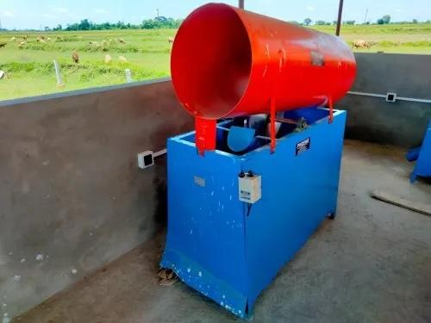

* Fiber extractors

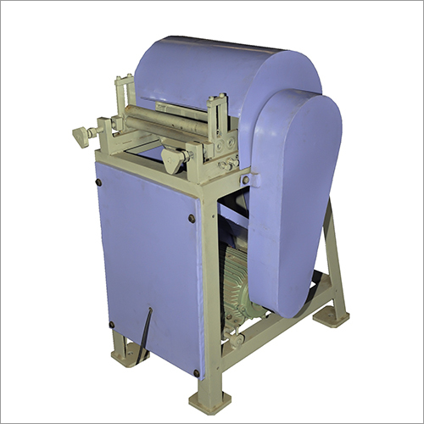

* Boiler

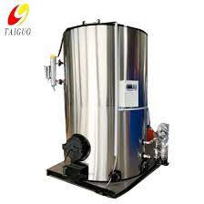

* Fibre chopper

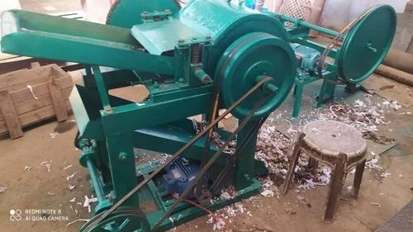

* Beater Machine

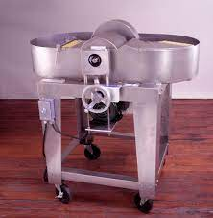

* Dryer/Hydro Extractor

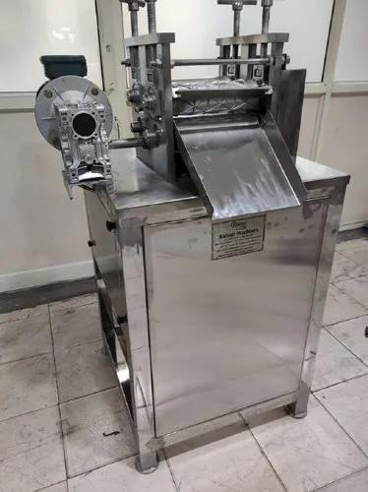

* Hammer mill/Pulverizer



* Core forming pieces of equipment

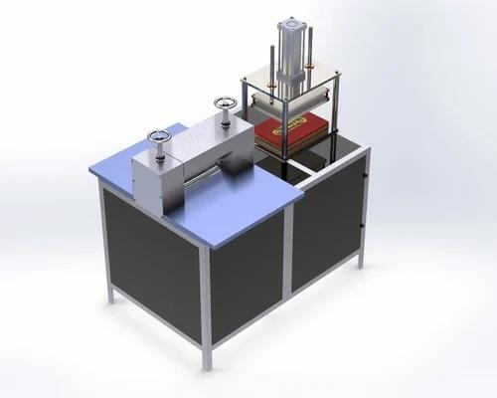

* Sanitization chambers



* Absorption Tester

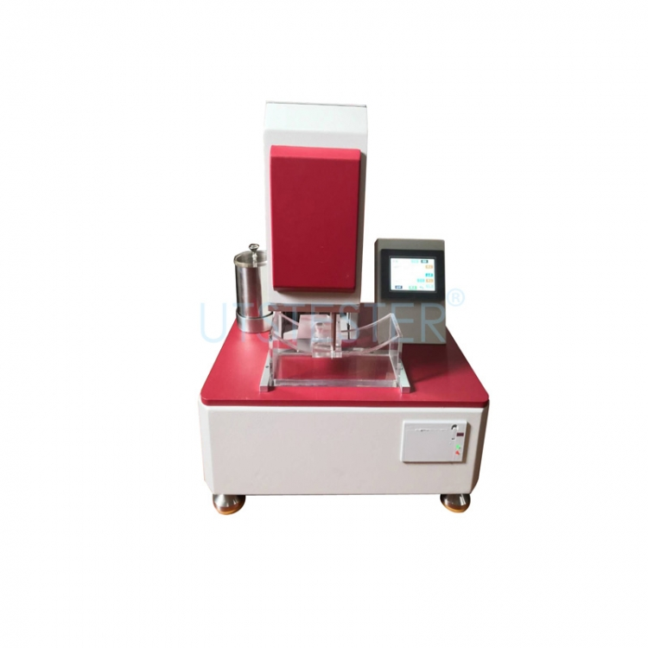

**Manufacturing Process**

Step 1 - Fiber Extraction: Banana pseudostems are fed into mechanical extractors to separate the long fibers from the core material.

Step 2 - Pulping: The extracted fibers are washed, cleaned, and boiled then mixed with water to make a pulp slurry. The pulp is screened to remove impurities.

Step 3 - Hydro Extraction & Drying - Water is removed.

Step 4 - Drying

Step 5 - Hammer Milling/ Pulverizing: Dried fiber sheets are milled into a loose, fluffy matrix ideal for absorbing fluids.

Step 6 - Core Formation: Fluff is layered onto a perforated banana bio-fabric. A second sheet is applied on top and sealed to form the absorbent pad core.

Step 7 - Sealing: The back and top perforated banana bio-fabric layers are ultrasonically sealed to encase the fluff core.

Step 8 - Cutting: Pads are precision laser cut into the desired shapes.

Step 9 - Sanitization: Pads undergo sanitization treatment in sealed chambers.

Step 10 - Packaging: Individual pads are wrapped in biodegradable plastic.:

**Quality Control**

* Machine calibrations will be performed daily to verify equipment is functioning optimally for pad fabrication.
* Dimensional checks will confirm pad lengths, widths, and thicknesses are within specified tolerances.
* Random sampling will select pads from each production batch for absorbency testing under controlled, simulated conditions. Pads must meet minimum fluid absorption and retention criteria.
* Bond strength testing will validate the seals between pad layers withstand movement and pressure during use.
* Visual inspections will identify any cosmetic defects.

Any pads not passing QC protocols will be rejected and recycled into the production stream.

**Sanitization**

* After fabrication, pads will undergo UV-C germicidal irradiation inside specialized sanitization chambers.
* UV-C light in the 260-270 nm wavelength range disrupts DNA bonds in microorganisms, rendering them unable to reproduce or grow.
* Pads will be conveyed through the UV chamber on a mesh belt. Lamps situated above and below will expose all pad surfaces to sufficient dosages of UV-C to sterilize them.
* UV intensity and belt speed will be optimized to achieve 99.9% sanitization efficiency while avoiding damage to pad materials.
* The automated, enclosed UV units allow safe and effective disinfection without chemical usage.
* Following UV treatment, a plant-based antibacterial spray will be applied as a final sanitizing rinse.

The UV-based sanitization system will sterilize pads before packaging in a low-cost, chemical-free process. All batches will be routinely tested for total microbial counts. This approach will enhance product hygiene and safety.

**Packaging**

Individual pads will be wrapped in PLA (polylactic acid) plastic for hygiene and protection. This Bio-plastic is compostable and derived from plant starches. Packages will contain brief instructions and branding. Packaging waste will be minimized and recycled.

**Waste Management**

Solid waste like banana stems and trimmings will be collected and provided to farms for composting or biofuel production. Liquid effluent will be filtered and treated before discharge. A full environmental impact assessment will be completed before operations.

**Financials & Investments**

|  |  |  |
| --- | --- | --- |
| PROJECT BUDGET | | |
| 1. | **Direct Expenses** | |
|  | * Custom stem cutter machine * Banana Fibre Extraction machines * Combing machine * Washing Bay * Fibre Cutting Machine * Boiler * Hollander Beater * Bleaching Bay * Hammer mill/Pulverizer * Pad Making Machine * Sanitation Chambers * Absorption tester * Weighing machine * Testing Lab Equipments * Drying Area * Factory Stainless Steel Countertops * Pumps and cleaning station * Safety Materials | Npr. 1,50,000  Npr. 5,00,000  Npr. 1,50,000  Npr. 25,000  Npr. 1,50,000  Npr. 45,000  Npr. 2,50,000  Npr. 25,000  Npr. 4,50,000  Npr. 18,25,000  Npr. 2,50,000  Npr. 15,000  Npr. 45,000  Npr. 50,000  Npr. 1,00,000  Npr. 1,25,000  Npr. 45,000  Npr. 50,000 |
| **Subtotal** - **Npr. 42,50,000** | | |
| 2. | Factory Building   * Computers *1 * Printers *1 * Tables & Chairs * Building Painting & renovations * Internet * Racks & Storage * Climate Control * Stationeries | Npr. 35,000  Npr. 20,000  Npr. 50,000  Npr. 1,75,000  Npr. 20,000  Npr. 75,000  Npr. 1,00,000  Npr. 25,000 |
|
| **Subtotal - Npr. 5,00,000** | | |
| 3. | Operations Contingency budget (6 months)   * CEO * Operations * Marketing * Finance & Admin * Workers (5 personnel) * Operations   + Electricity   + Waste management   + Rent   + Marketing   + Transportations | Npr. 3,00,000  Npr. 1,80,000  Npr. 1,50,000  Npr. 1,80,000  Npr. 4,50,000      Npr. 60,000  Npr. 45,000  Npr. 2,70,000  Npr. 2,40,000  Npr. 2,10,000 |
| **Subtotal - Npr. 20,85,000** | | |
| **TOTAL PROJECT BUDGET (1+2+3) - NPR 6,835,000** | | |

**Marketing and Sales Strategy**

**Target Customers**

The core target audience is poor/ middle-class women aged 21-45 in urban Nepal concerned about health, affordability, and the environment. Secondary targets are adolescent girls needing menstrual products.

**Pricing**

Pads will be affordably priced at NRs 250 for a pack of 15 pads. Pricing competitively against major brands while earning profit margin. Different size packs will have slight price variations.

**Distribution Channels**

Pads will be sold through Distribution Partners, Pharmacies, General stores, NGOs, Schools, and Direct-to-consumer channels. Partnerships will improve market access nationwide. E-commerce platforms will also be leveraged.

**Promotions Strategy**

* Educational marketing focused on the benefits of banana fiber pads
* Influencer marketing partnerships
* Digital ads on Google, Facebook, and Instagram
* Sponsoring health camps and community events
* Promotional pricing and sampling when launching

**Implementation Timeline**

* Market research: Month 1 - Complete
* Source investment: Months 2-3 - Ongoing
* Secure raw material supply contracts: Months 3-4 - Complete
* Factory setup: Months 5-8
* Recruit and train staff: Months 7-9
* Install equipment: Months 8-10
* Trial production runs: Months 10-11
* Quality testing and certification: Months 12
* Marketing launch: Month 13
* Start full-scale production: Month 14

**Risks and Mitigation Strategies**

Risks include raw material price fluctuations, recruitment challenges, machinery breakdowns, and consumer skepticism. These will be mitigated through long-term supplier contracts, competitive hiring, preventative maintenance, and educational marketing.

**Regulatory Environment**

**Product Testing and Certification**

The manufacturing facility and products will undergo certification by the Nepal Bureau of Standards and Metrology for quality standards. Biocompatibility testing will ensure pad materials are non-toxic and safe. Absorbency and durability will be verified through laboratory testing.

**Legal and Compliance**

The company will comply with all national environmental, labor, safety, and waste disposal regulations. Business permits and licenses will be obtained. Consulting firms can assist with regulatory navigation.

**Conclusion**

In conclusion, this proposal demonstrates a strong business case for establishing a banana fiber sanitary pad manufacturing company in Nepal. The sustainable, eco-friendly products will benefit customers, agricultural communities, and the environment. With proper planning and management, the company will be poised for market leadership and profitability in the feminine hygiene space. The timeline and budget are feasible, and risks can be mitigated. We look forward to bringing this innovative business to fruition.

**References**

[1] Grand View Research. (2019). Feminine Hygiene Products Market Size, Share & Trends Analysis Report By Product (Sanitary Pads/Napkins, Tampons, Panty Liners), By Region (North America, Europe, APAC, CSA, MEA), And Segment Forecasts, 2019 - 2025.

[2] UNICEF. (2019). Guidance on Menstrual Health and Hygiene. Kathmandu, Nepal: UNICEF Nepal Country Office.

[3] Chaudhri, S.K., Jain, N.K., & Singh, V.P. (2003). History of Hygiene Menstrual Pad. Asian Journal of Medical Sciences, 5(2), 29-31.

[4] Plastic Waste Management in Nepal. (2020). Heinrich Böll Foundation.<https://np.boell.org/en/plastic-waste-management-nepal>

[5]WWF Nepal. (2020). Rhetoric to Action: Fighting the Plastic Pandemic in Nepal.<https://www.wwfnepal.org/>